Part III: A Poetry Book
Original Poetry Created by Student Participants
In Theatre in Motion’s
Creative Drama, Poetry, and Universal Design for Learning Residency

The participants ranged in age from 6 to 72 years old,
all with celebratory abilities and disabilities!

Visual art is included, which was created by students and Theatre in Motion artists.

Showcased are LIST POEMS and HAIKU.

© 2017 Leslie Fanelli, Artistic Director

Theatre in Motion

Funded by the J.M. McDonald Foundation

List Poems Inspired by Works Created by Theatre in Motion Artists
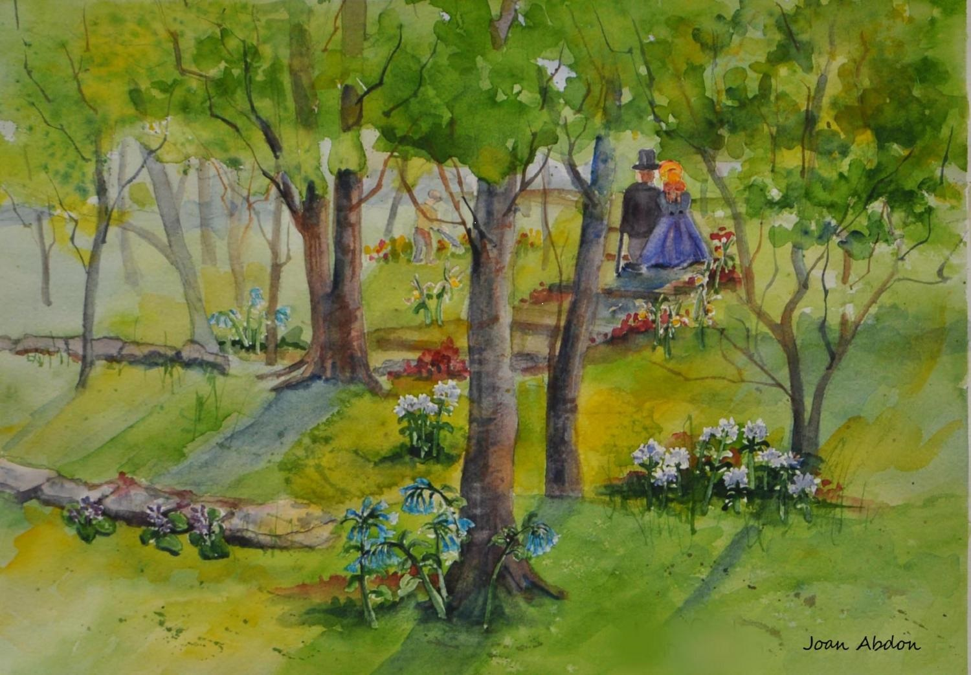
Once Upon a Time So many years
When? Trees and shadow
Wish to be there Top hat
Greenest green Blue velvet dress
Blue flowers
Curvy Trees

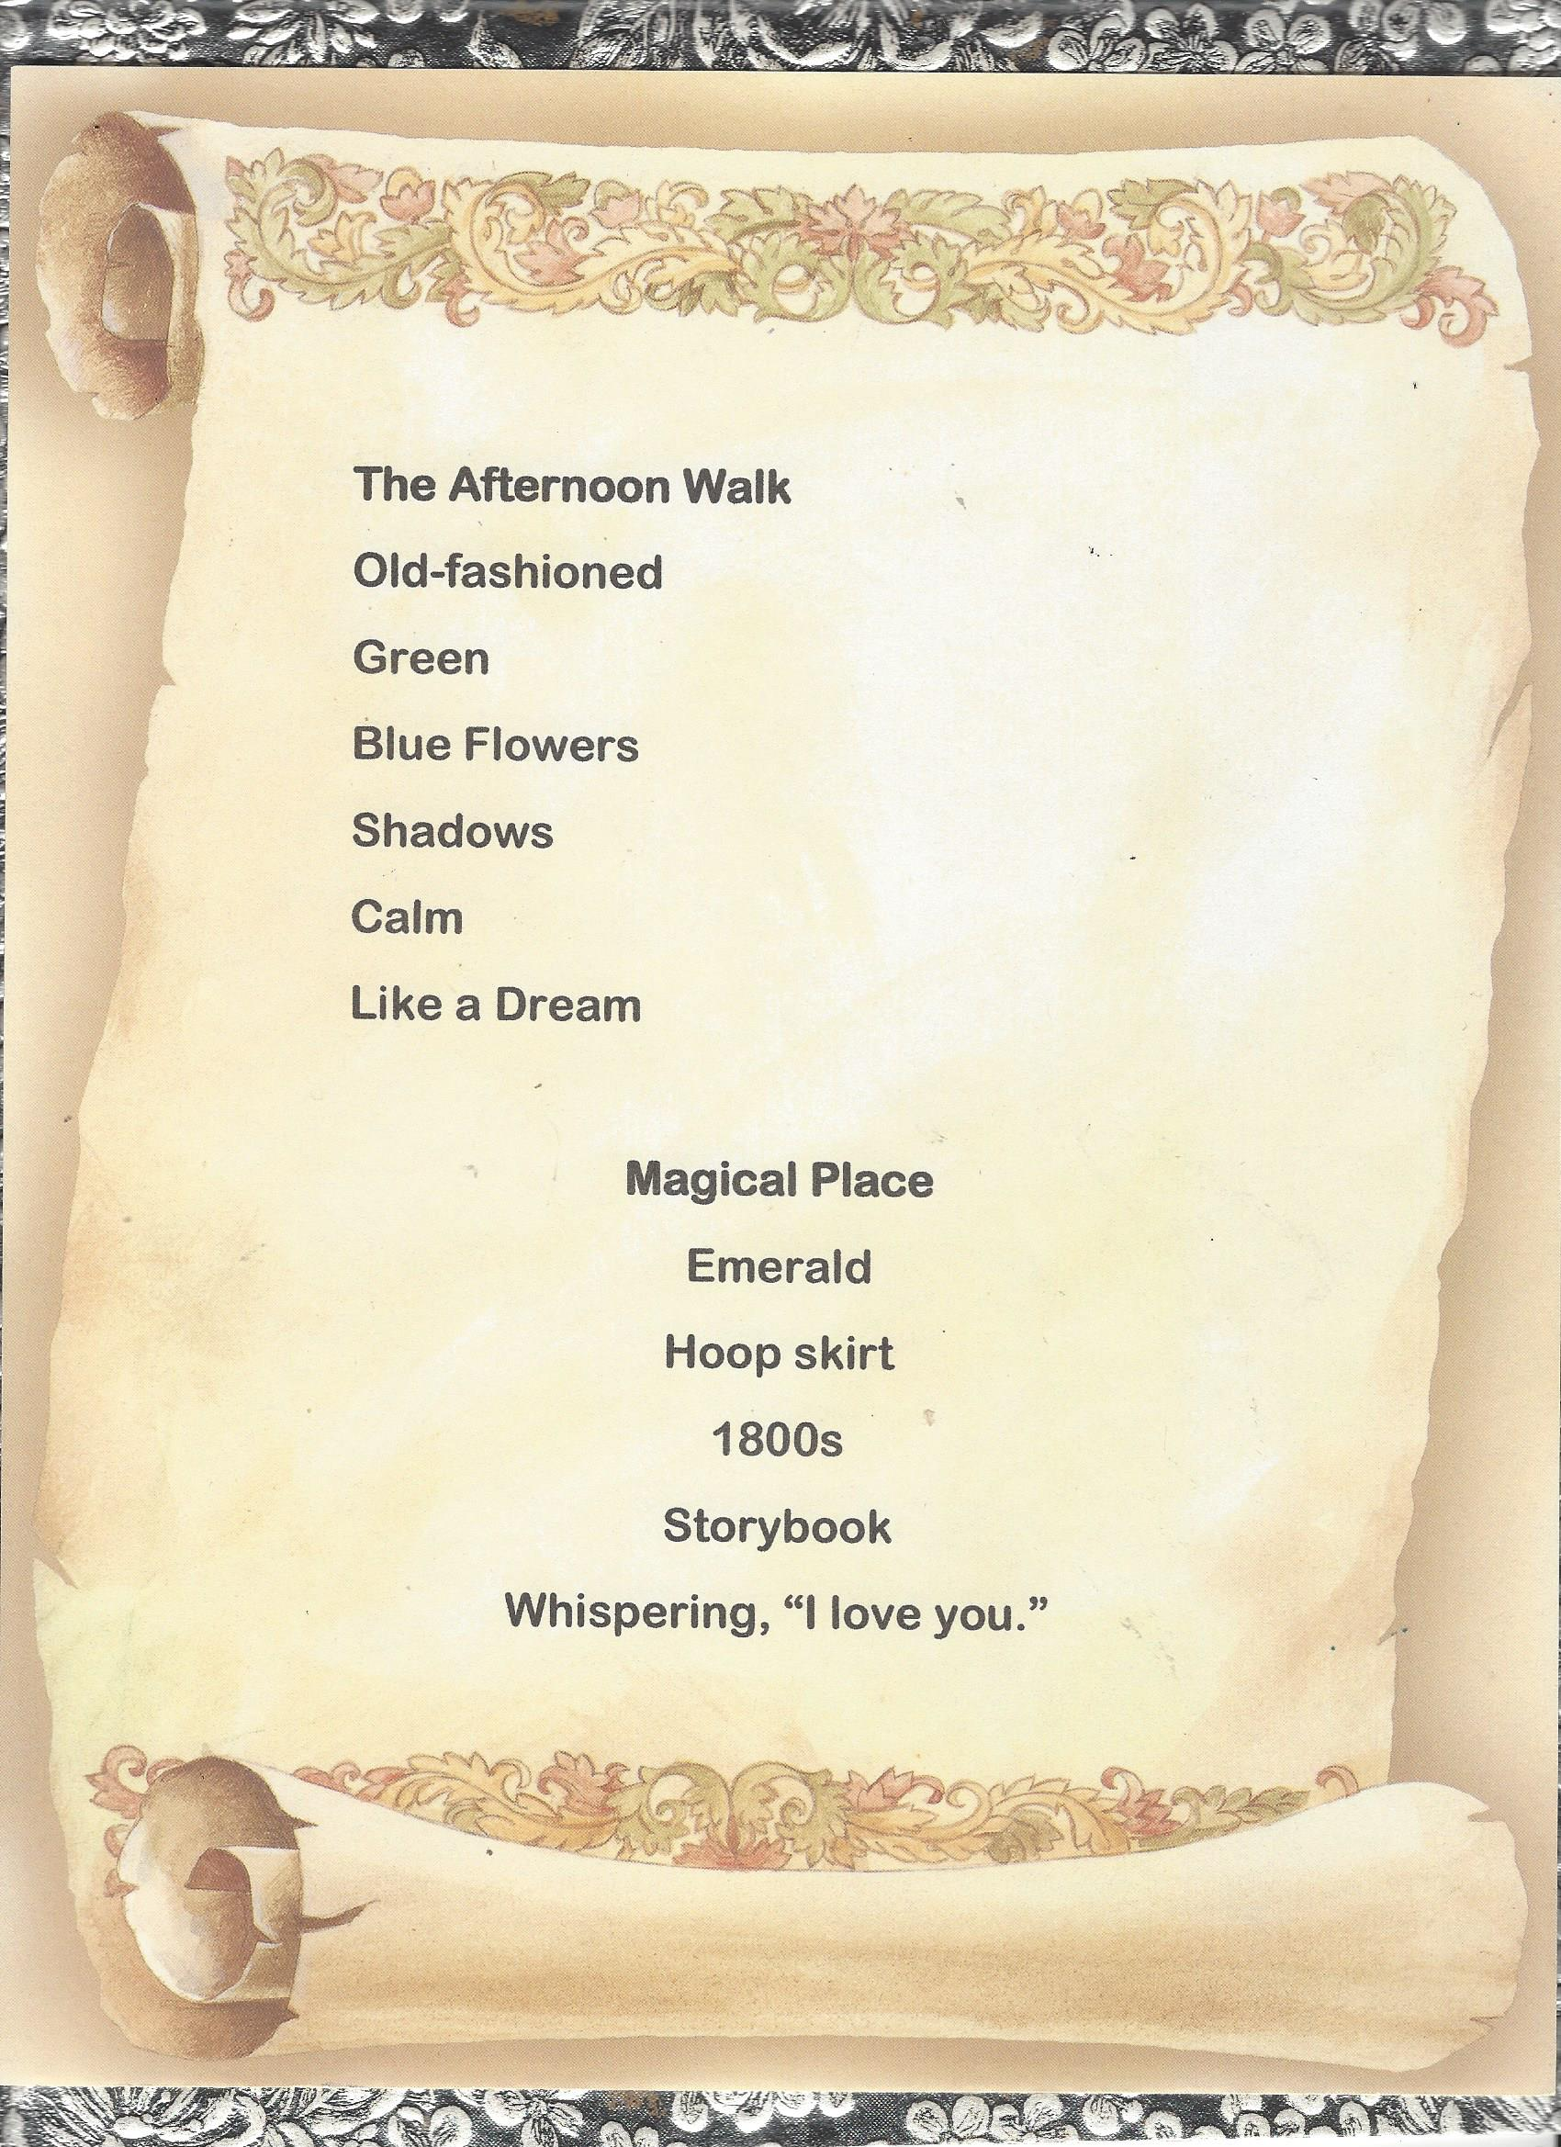
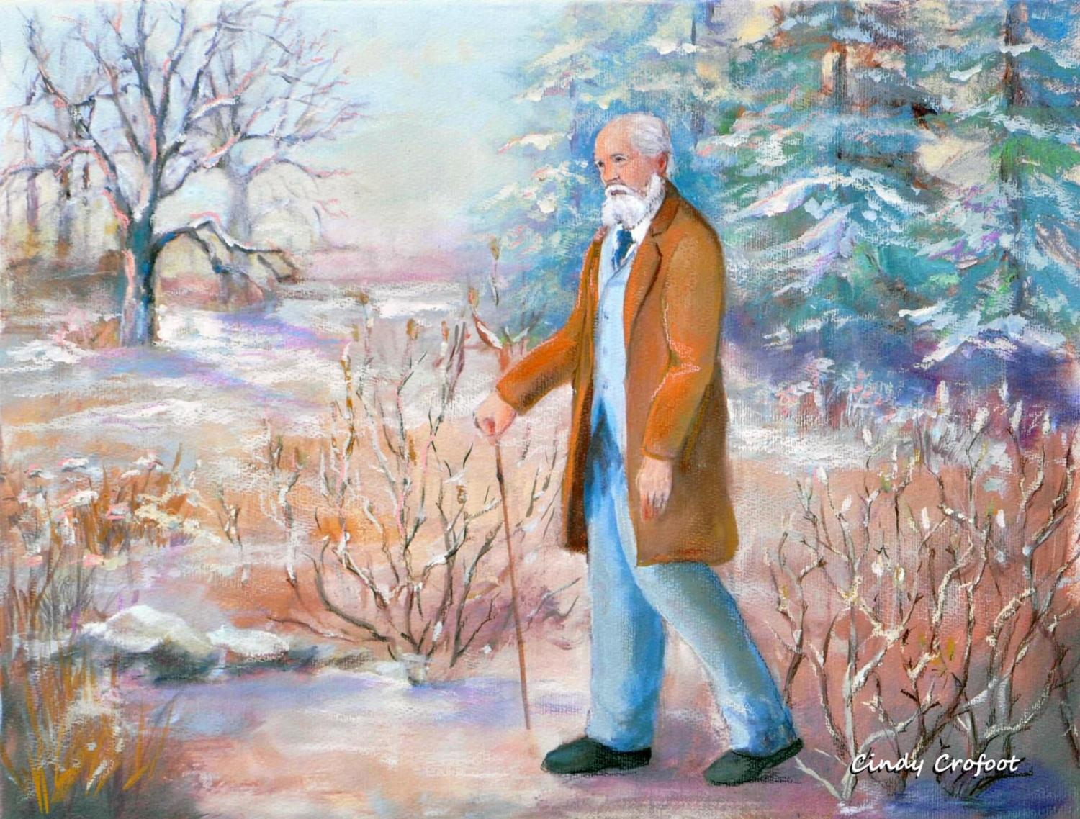

Frederick Law Olmsted Winter Wonder
Winter Ice Pines Trees
His Landscape Branches Hang
Today and Way Back Then No gloves?

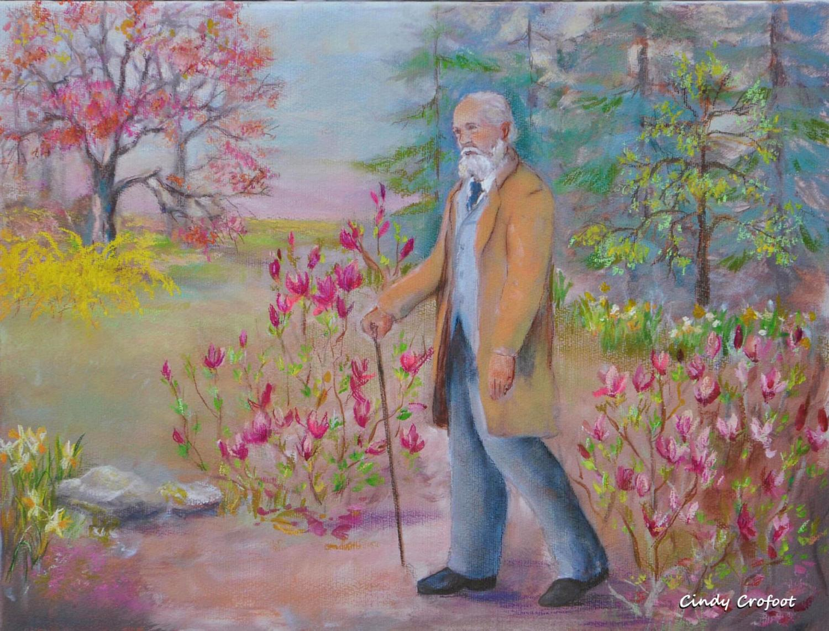

Now it is Spring! New Flowers
Fantastic Forsythia bush
Loveable Pink
Optimistic Red
Wonderful Green grass

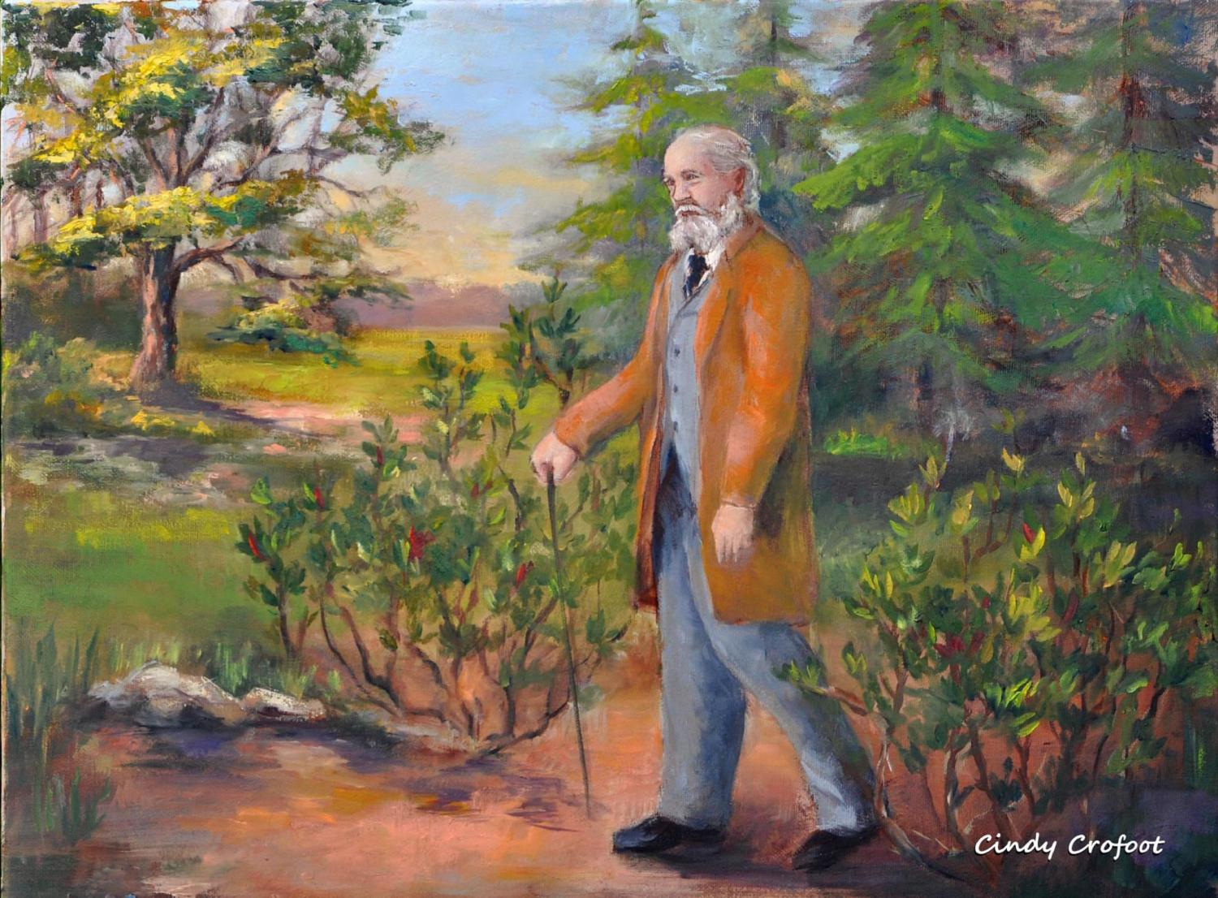

Summer Is Best I Think It Is Saturday!
Hot, but not too hot Why? Well, because
Just right Summer Saturday rocks.
Halfway Through the Year
Time Stands Still

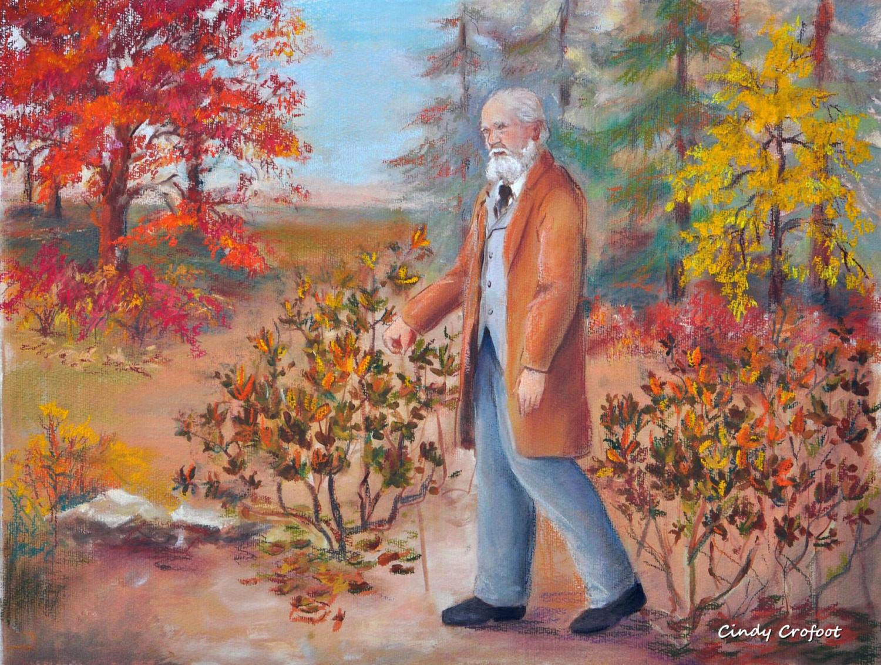

Olmsted in the Fall Soft Shoe
Orange No leaves by feet!
Red Not yet
Brown Soon
Yellow and Blue

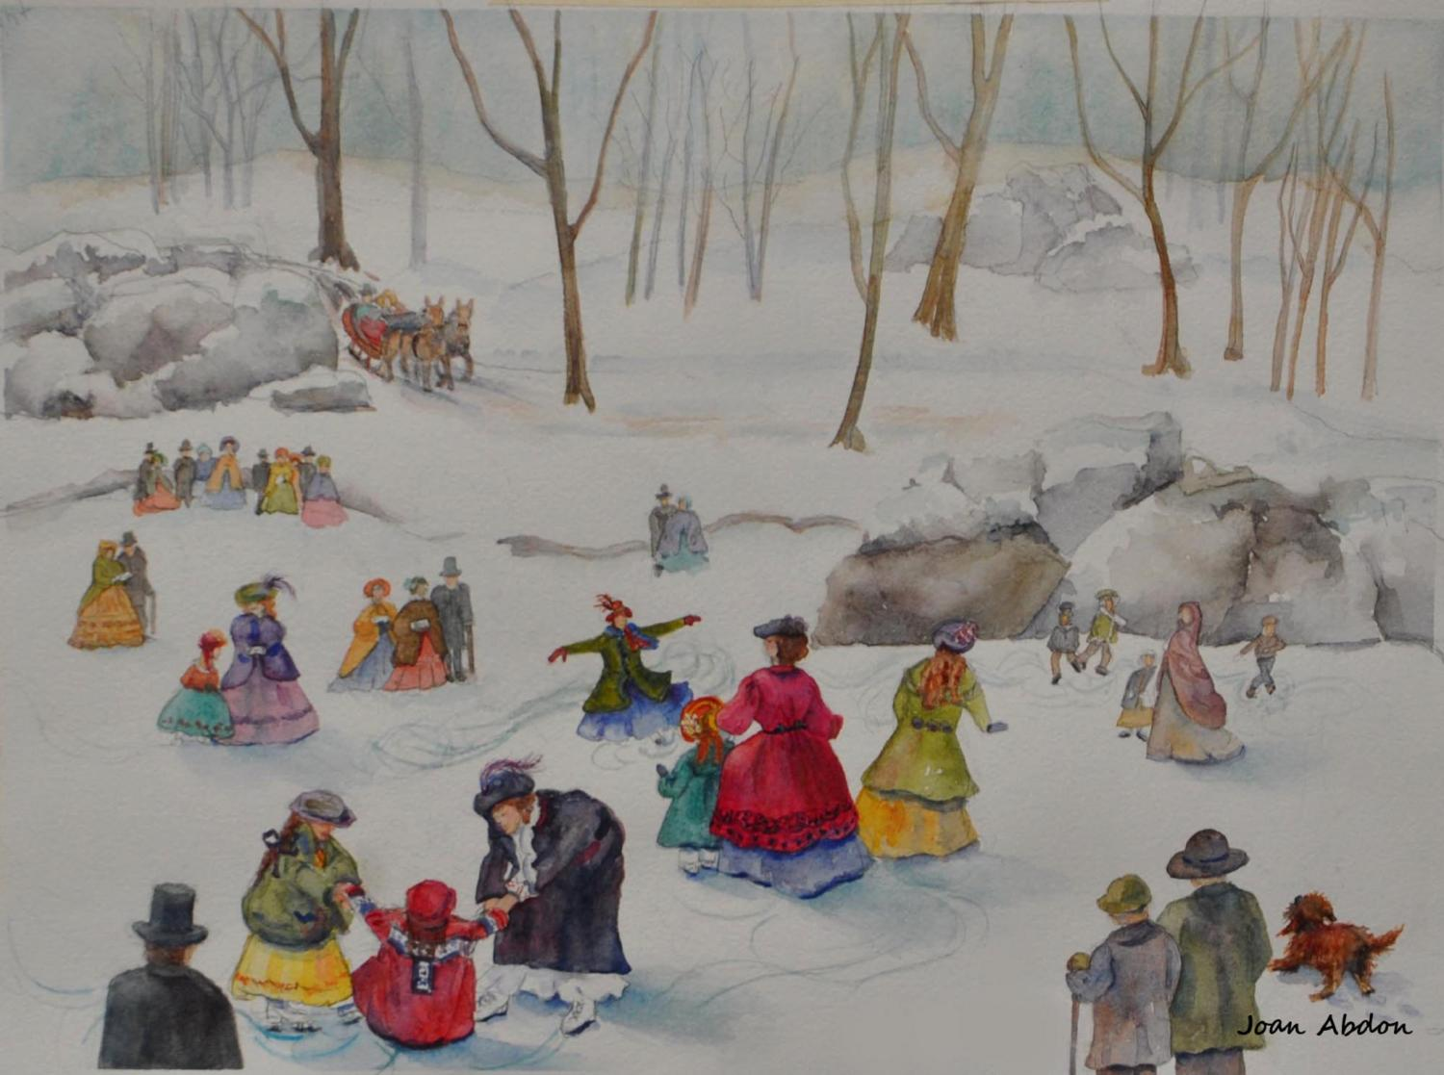

Ice Skating Bright Red And …
Fun Yellow
Big skirts White
Happy dog Icy
Spinning Hats galore!
Almost falling Snow
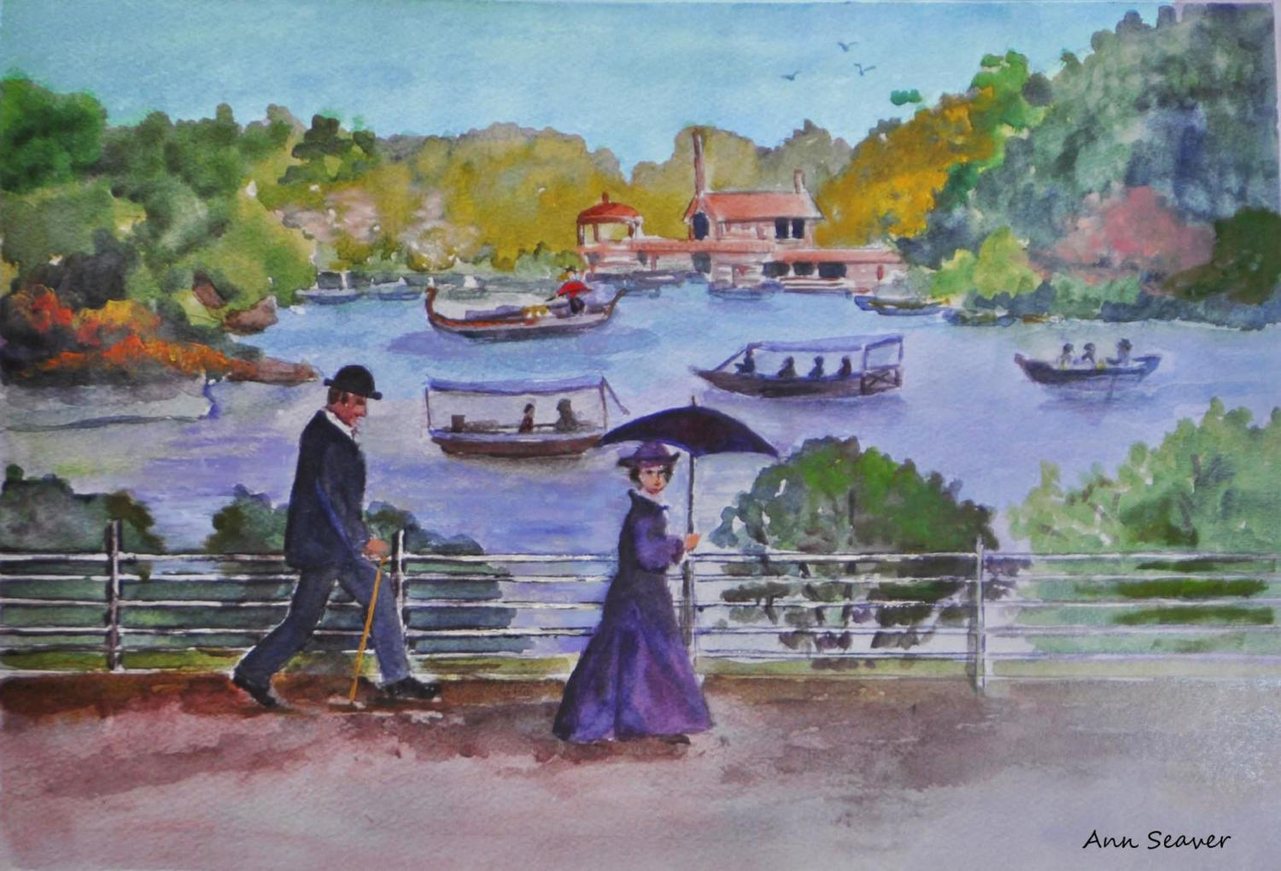

The Lake
She is looking at me!
Her Umbrella
His Cane
Boats
Gondola
Long Ago and Far Away
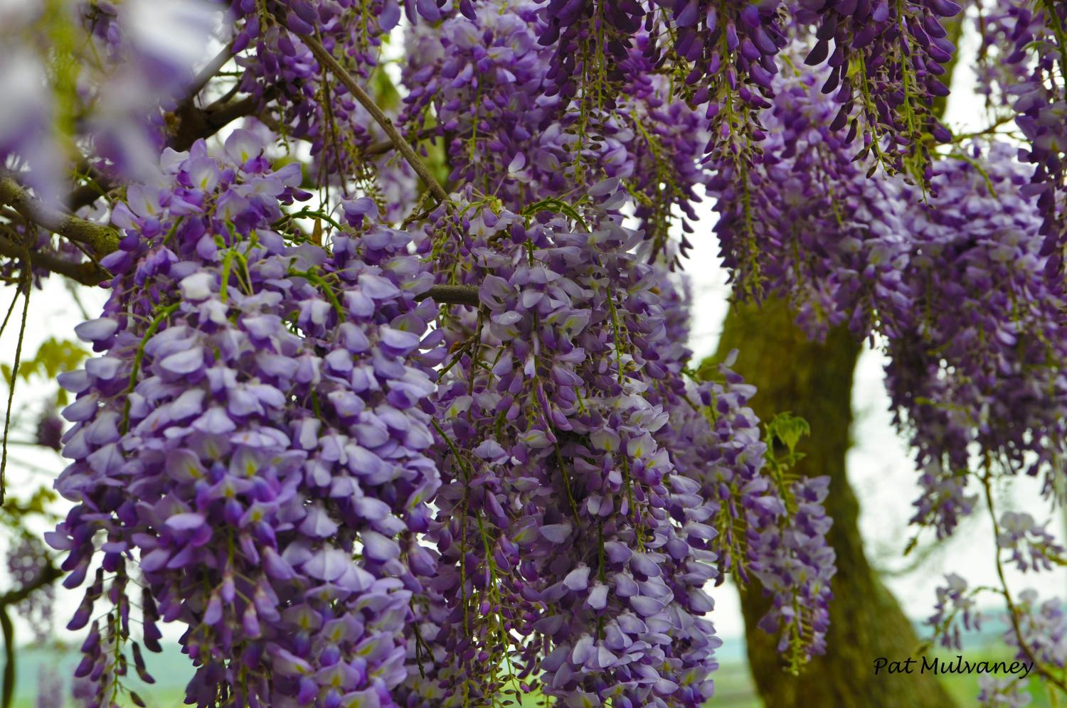

Wisteria
Purple Blossoms
Branches Hanging
Curves Loveliness
Shapes
Smells Beautiful
Spring Heaven

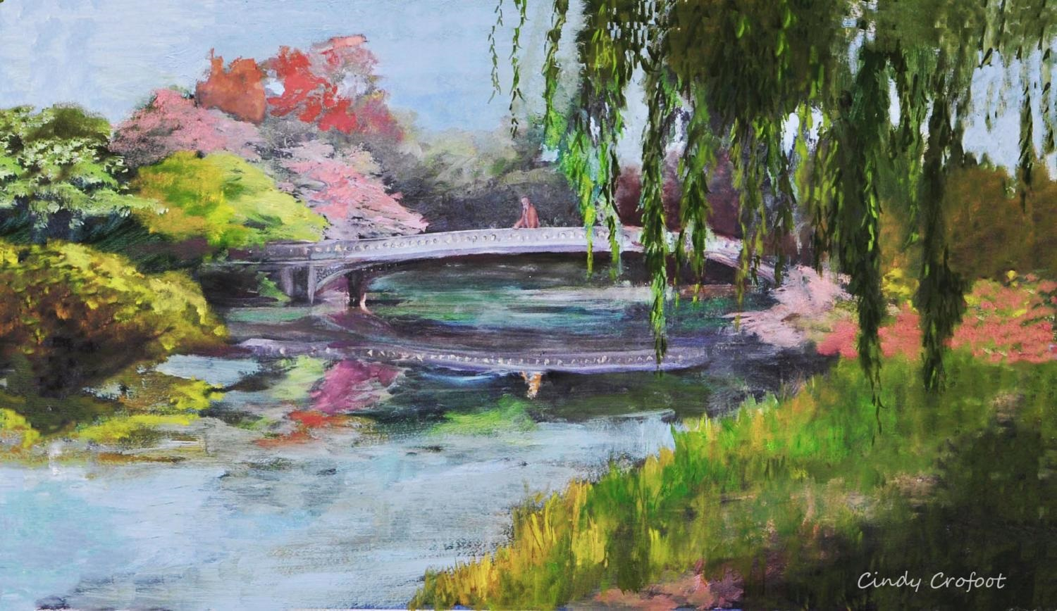

My Bridge Day to Love
Beautiful, quiet lake Light wind
Multi-colored scenery Sunny
Lovely arch invites me. Spring
Calm day
Spring is everywhere.

Outdoor Secret Spot
You and me
Pipe tonight
the moon
Away from sun
moving

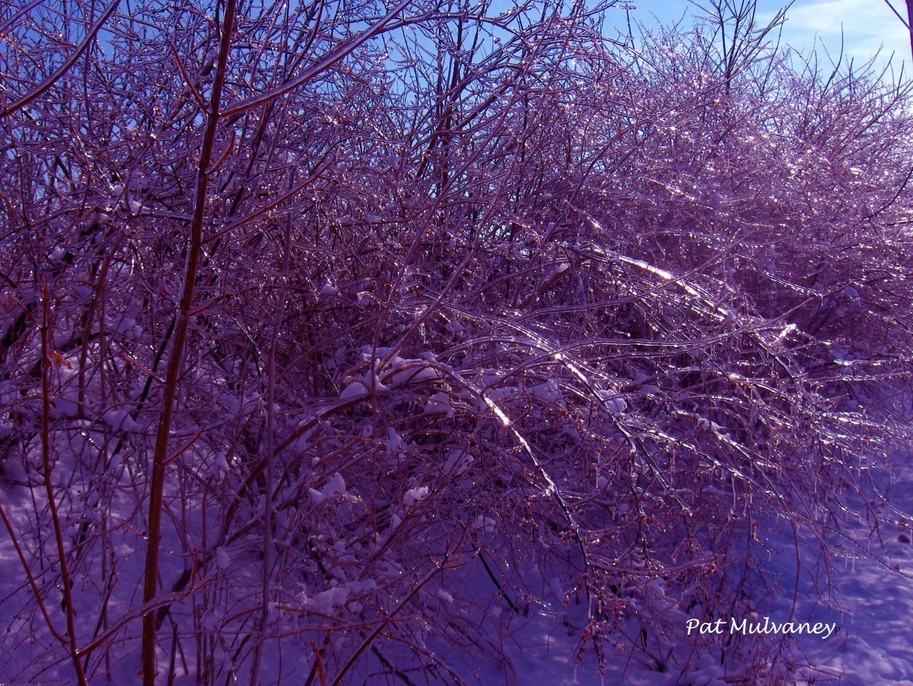

Cold Blue Ice
Winter Freezing
Lovely Shiny
Crying Brrrrrr
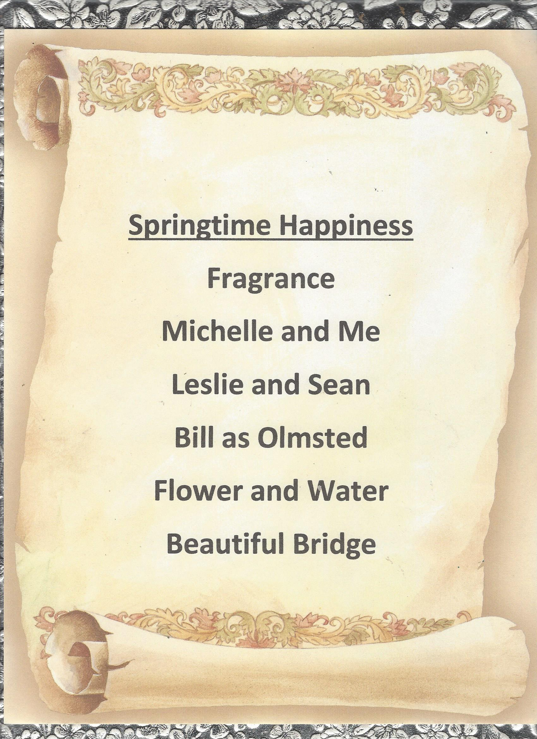
The sky

Stone bridge

Petals

Leaves

Clouds

The sun

Might rain

A lake
A shore
sweeping trees
Bushes abound
Love to be there
Happiness
birds
Day to remember
Sun and shadows
Forever and ever

Curved windows
Reading spot
Branches around
Nice to be there

Reflection
Me or him?

And now it is time for
Haiku …

Behold, group efforts:



Black and white around
Eerie and lovely, spooky
Scary and pretty
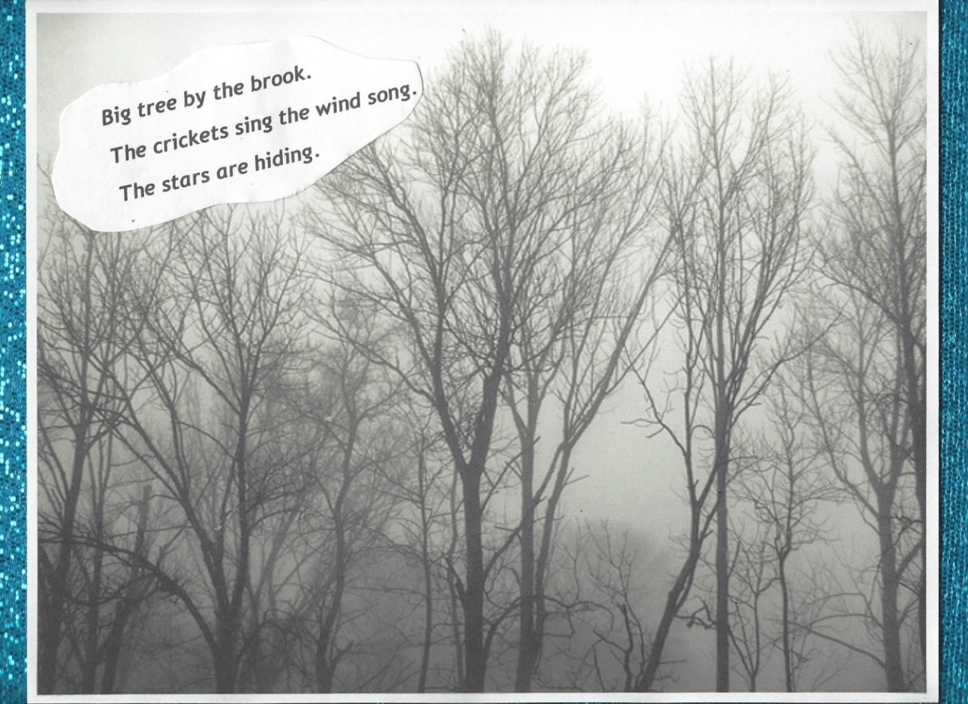

Aaaaaaaaaaaaaaaaaaaaaaaaaaah
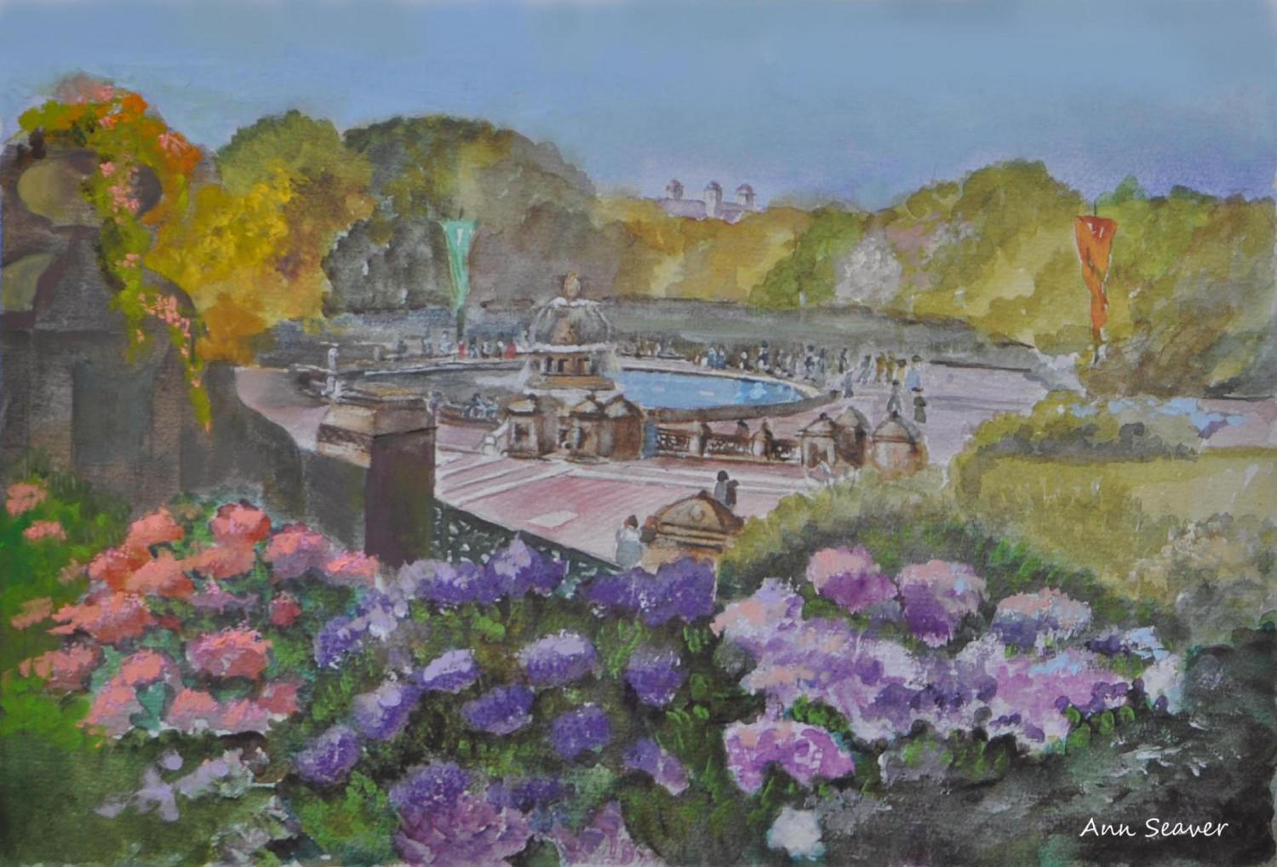

Outdoors pinkish green
Purple, lavender colors
Grateful for the park

I see a fountain.
Faraway people gather.
Listen to the spring.
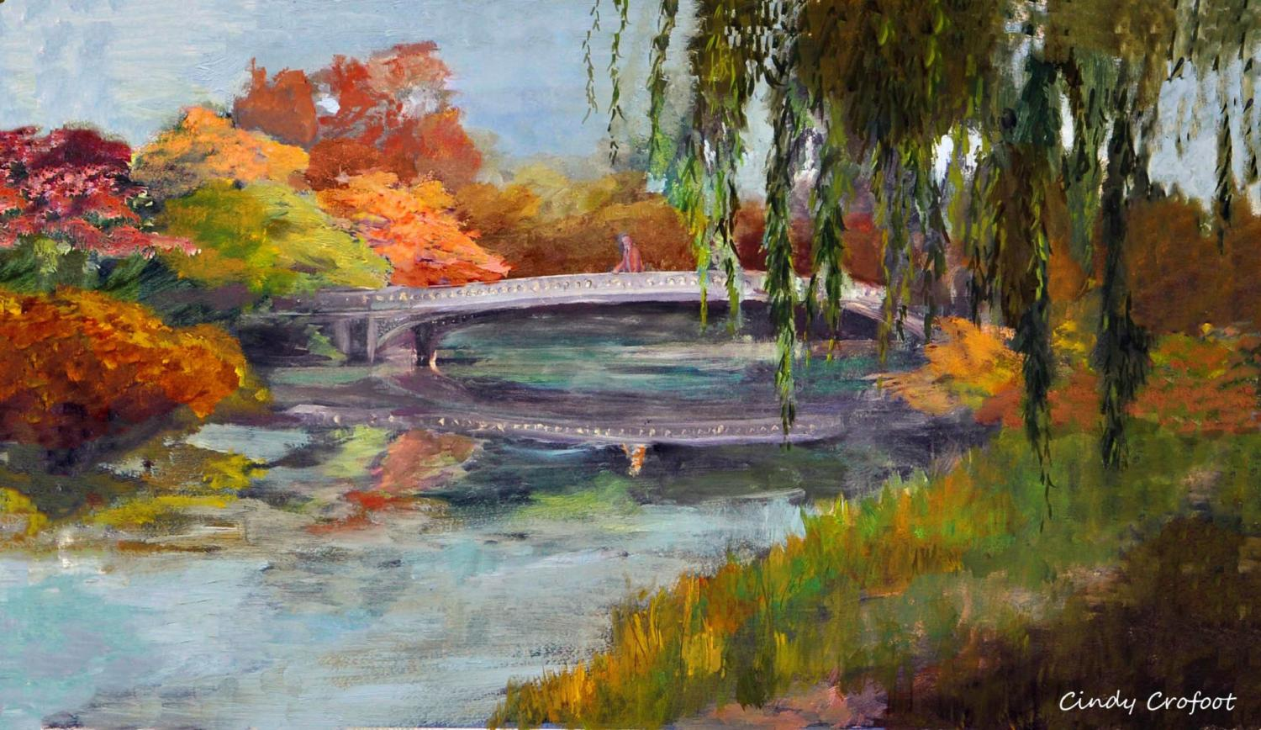

Autumn is so fine.
I like to take long, long walks.
Over the bridge, and …

Bow Bridge in the fall
Weeping willow reflects Bill.
He is our Olmsted.

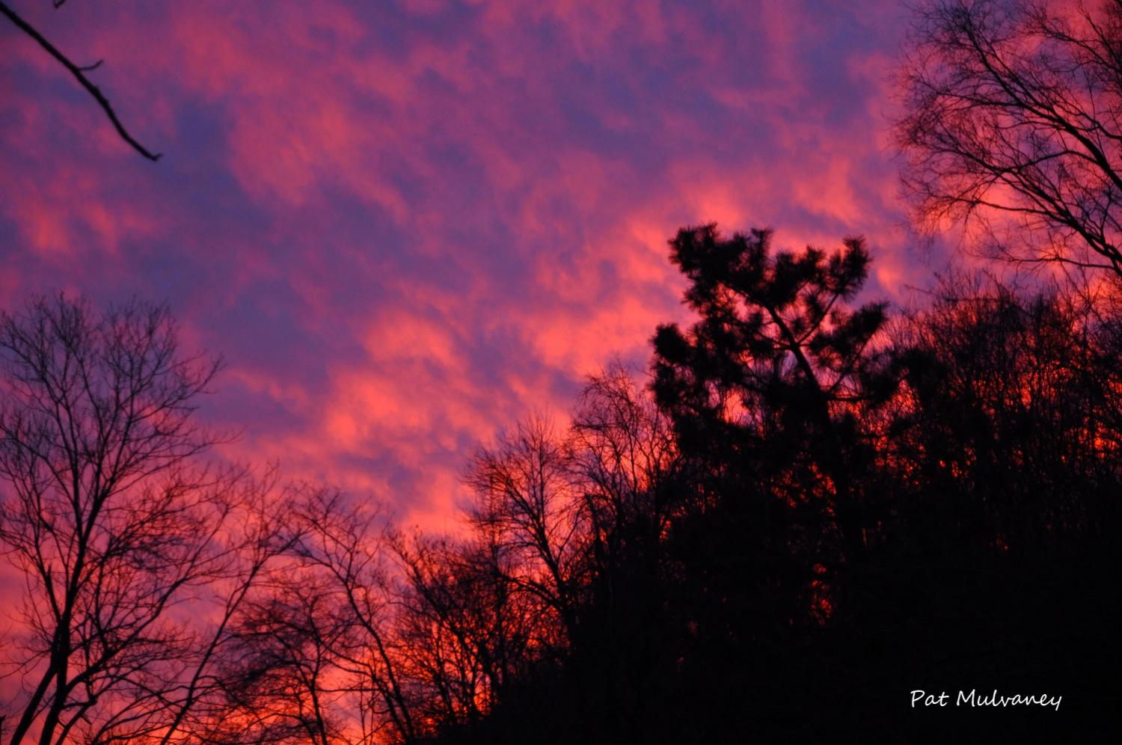

Shadows pink blue-ish
Outlines of trees sadness still
Beautiful and Sad

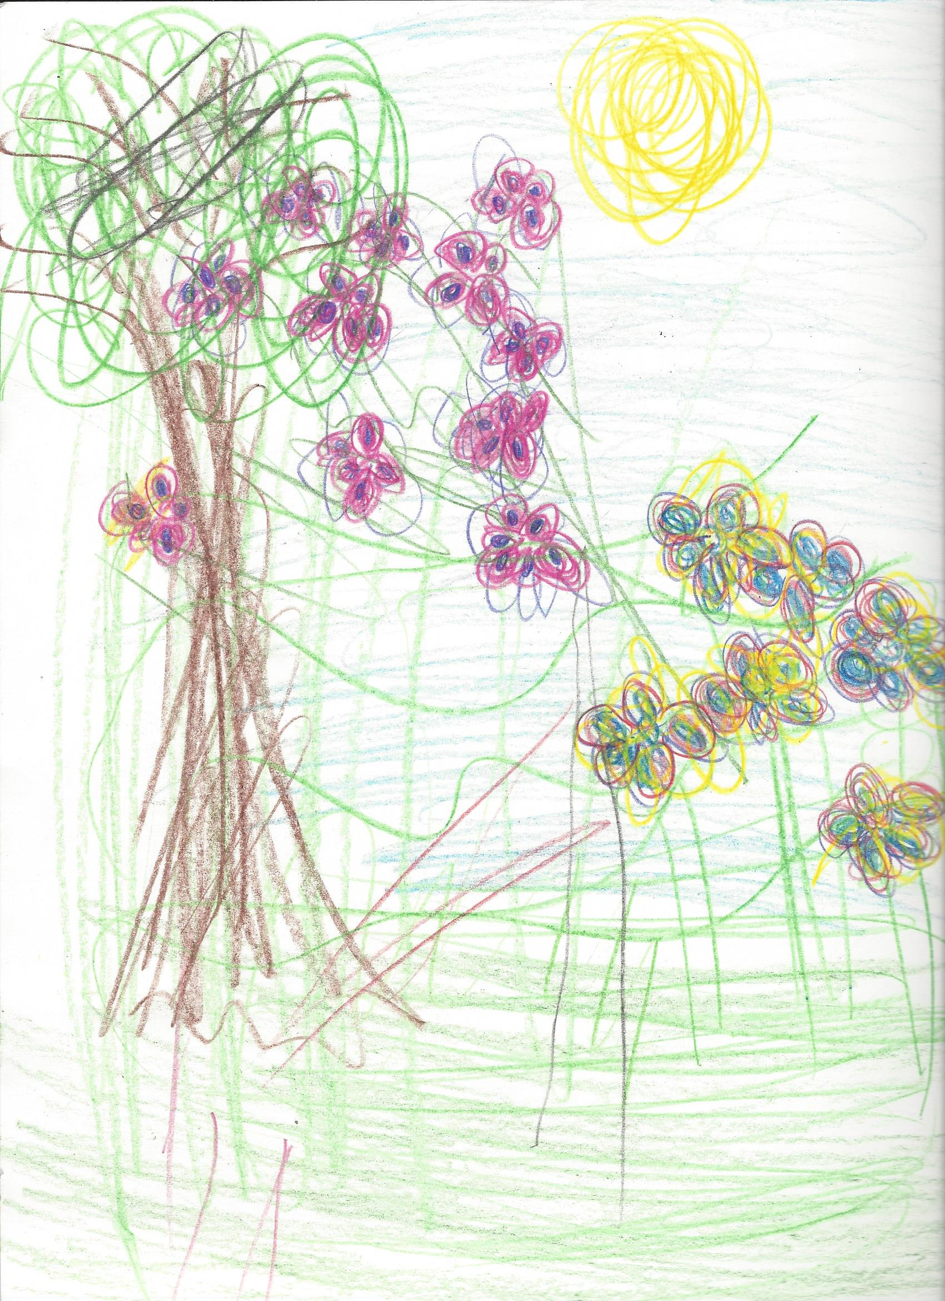
Poetic License with 5-7-5 construct was discussed and utilized.
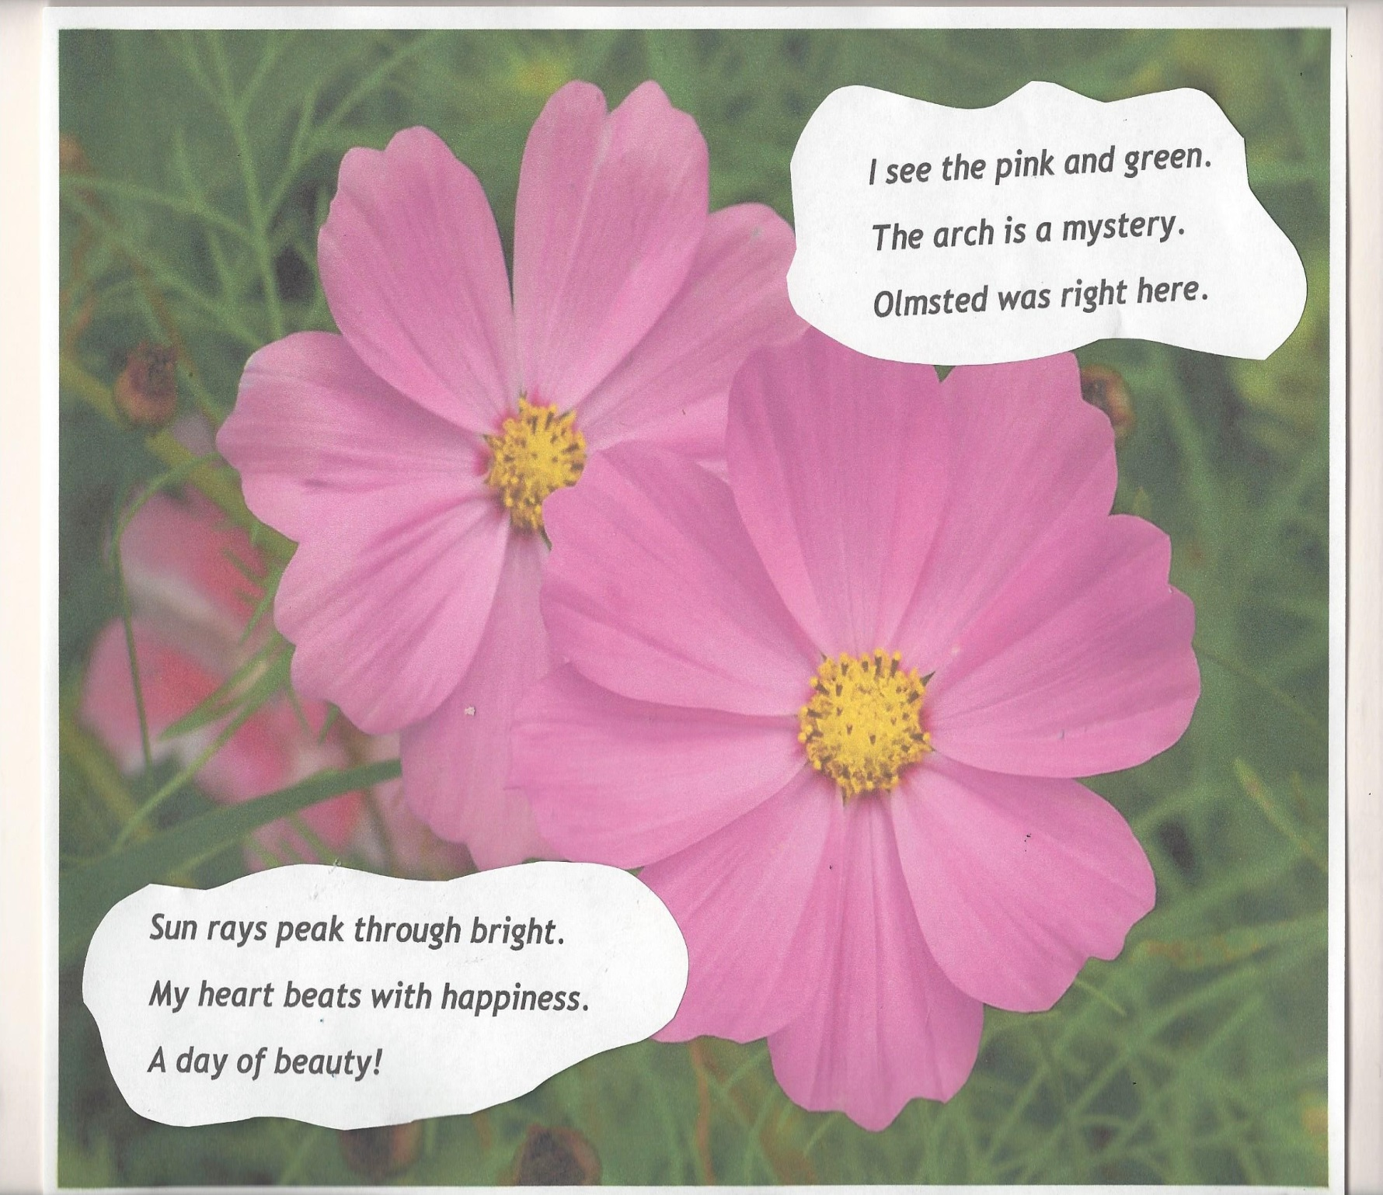
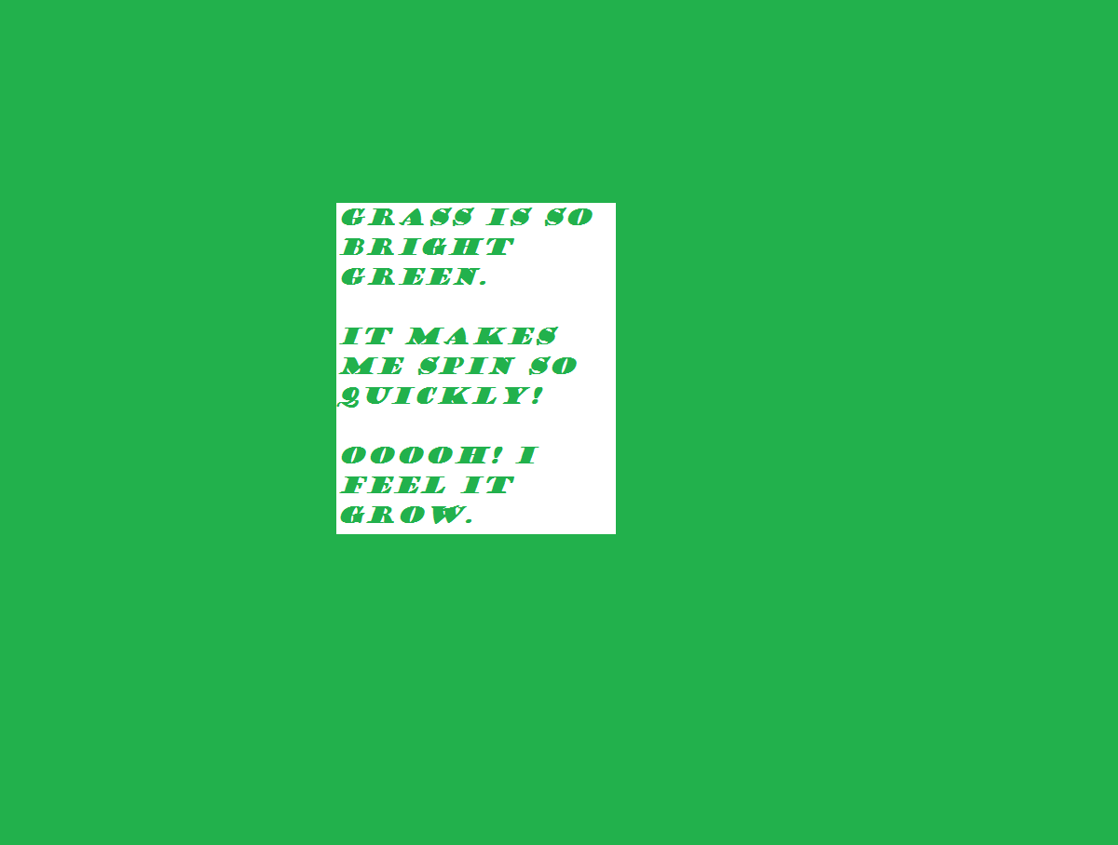
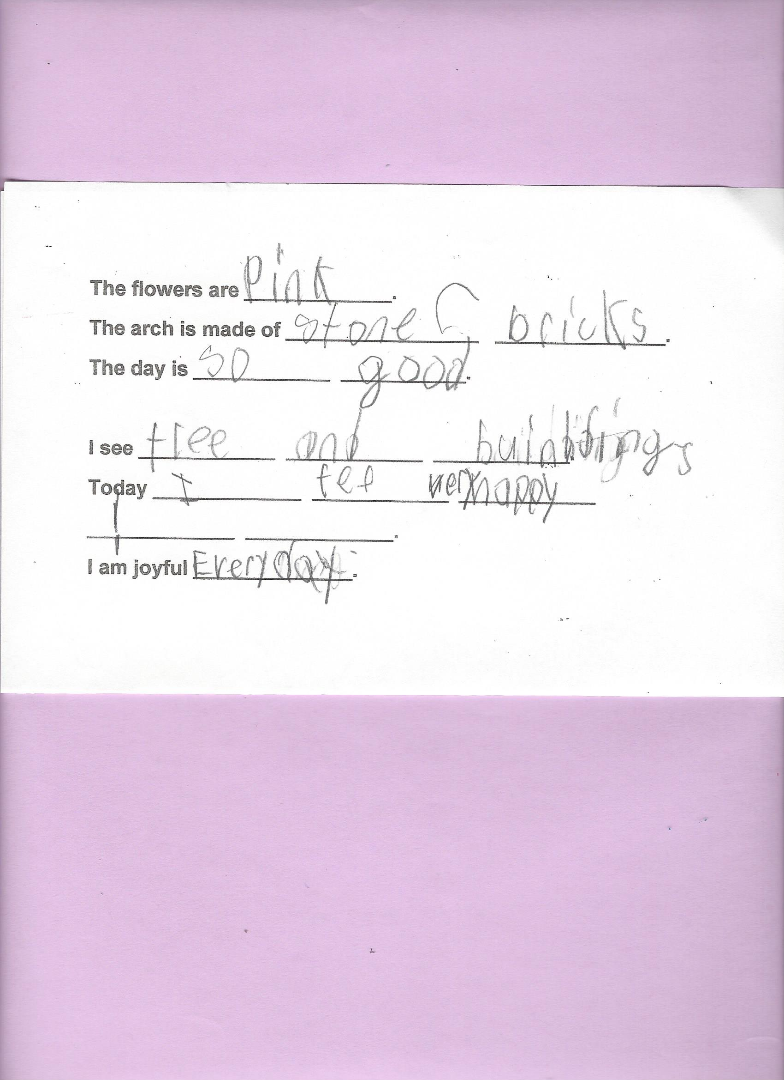

Metamorphic rocks
All near the crashing ocean
Volcanoes were here.

Sedimentary
Have changed over time
To me, they are best.

Petals are so red.

Lilac blooms rest in the front.

All over it’s green.

